UNIVERSITY OF DAR ES SALAAM



COLLEGE OF INFORMATION AND COMMUNICATION TECHNOLOGIES (CoICT).

DEPARTMENT OF ELECTRONICS AND TELECOMMUNICATION ENGINEERING.

ES 499: FINAL YEAR PROJECT

FINAL REPORT

A PROJECT REPORT IN FULFILMENT FOR THE AWARD OF BACHELOR OF SCIENCE IN ELECTRONICS ENGINEERING (BSC. ELE)

|  |  |
| --- | --- |
| PROJECT TITTLE: | SECURED WIRELESS USB FLASH DRIVE. |
| STUDENT`S NAME: | KOWERO, WALIDI WAZIRI |
| REG. NO: | 2020-04-04390 |
| PROGRAM: | BSc. IN ELECTRONICS ENGINEERING |
| SUPERVISOR`S NAME: | PROF BARAKA MAISELI. |
| SUPERVISOR’S SIGNATURE: | ……………………………. |
| STUDENT’S SIGNATURE: | ……………………………. |
| SUBMISSION DATE: | 01st, JULY 2024 |

DECLARATION I, KOWERO, WALIDI WAZIRI., declare that this report and the works described in it are my own work completed as part of my studies at University of Dar es Salaam. All contributions and references of others have been expressly acknowledged and/or cited.

KOWERO, WALIDI WAZIRI

…………………………………………..

Date:

…………………………………………..

# ABSTRACT

This project aims at utilizing this advancement in technology that we have achieved so far to develop a secured wireless system that can perform seamless data transfer to the client over different operating systems. The system tries to increase the mobility and freedom and provide more options to the user towards the access of information.

TABLE OF CONTENTS

ABSTRACT ii

LIST OF FIGURES iv

LIST OF ABBREVIATIONS v

CHAPTER ONE 1

INTRODUCTION 1

Background 1

PROBLEM STATEMENT 3

OBJECTIVES 3

Main objective 3

Specific Objectives 3

LITERATURE REVIEW 3

REQUIREMENT GATHERING 5

METHODOLOGY 8

Concept generation 11

Flowchart 20

Use Case 23

Relation Diagram 25

Sequence Diagram 25

EXPERIMENTATION 26

Usb flash drive initial design 27

Web interface Simulation 30

Locally programmed usb flash drive with wireless features 32

Locally Manufactured design of WEUSBFD 37

ESP32 Based USB Flash Drive 39

CONCLUSION 42

Recommendations 42

Challenges 42

REFERENCES 44

APPENDICES 45

TIME SCHEDULE 45

BUDGET 45

# LIST OF FIGURES

Figure 1 Basic Scheme of a semiconductor memory cell 1

Figure 2 A typical USB Flash Drive 6

Figure 3 Concept fan for available Controller options 12

Figure 4 Difference between ESP32-S3-WROOM-1-N8, ESP32-S3-WROOM-1-N8R2, ESP32-S3-WROOM-1-H4 and ESP32-S3-WROOM-1-N16R16V. 14

Figure 5 Difference between ESP32-S3-WROOM-32E-N4, ESP32-S3-WROOM-MINI-1-N4, ESP32-S3-WROOM-32UE-N8 and ESP32-S3-WROVER-IE-N16R8, ESP32-WROOM-DA-N8. 15

Figure 6 Difference between ESP32-S3-WROOM-32-N4, ESP32-S3-WROVER-IE-N4R8, ESP32-S3-WROVER-IB-N4R8, ESP32-S3-WROVER-I-N4R8 and ESP32-S3-WROOM-32D-N4. 15

Figure 7 The main program workflow 17

Figure 8. Samba Server Flowchart 18

Figure 9. Web Server Flowchart 19

Figure 10. Use Case 20

Figure 11. Entity relation diagram 21

Figure 12. Sequence diagram 22

Figure 17. Simulation on wokwi. SD card is used in place of Nand Flash memory to demonstrate non-volatile file storage. 23

Figure 18.Interactive Web file server as output after simulation 23

Figure 13. The initial design of usb flash drive 25

Figure 14. 3D view of the initial design 25

Figure 15. Manufactured PCB Boards for the initial design 26

Figure 16. Testing of the initial board 26

Figure 19.Experimented circuit on the board 28

Figure 20.Experimented circuit is visible as a usable flash ready to format for general uses 29

Figure 21. Present user interface. User is automatically redirected to this page connected to this device’s Wi-Fi. Like TTCL-WIFI 2 and WIFI 4U. 30

Figure 22. Schematic design of the prepared circuit 31

Figure 23. Prepared PCB layout 32

Figure 24. 3D layout of the prototype 32

Figure 25.Time Schedule 33

# LIST OF ABBREVIATIONS

|  |  |  |
| --- | --- | --- |
| **Abbreviation** |  | **Long form/meaning** |
| CUWB | - | Ciholas Ultra-wideband |
| eMMC | - | Embedded Multimedia card |
| SMB | - | Server Message Block |
| NAS | - | Network attached Storage |
| NFS | - | Network File system |
| PCB | - | Printed Circuit Board |
| SOC | - | System on Chip |
| USB | - | Universal Serial Bus |
| UWB | - | Ultra-wideband |
| WEUSBFD | - | Wi-Fi Enabled USB Flash Drive |
| Wi-Fi | - | Wireless Fidelity |
|  |  |  |

# CHAPTER ONE

## INTRODUCTION

### Background

Majority of the storage technology have been largely improved in term of speed, capacity and reliability over the past 20 years. Some of the major discovery include

* discovery of Magnetic tape (1930) which uses a plastic tape containing magnetic material which creates a certain pattern of potential difference when passed through magnetic sensor. This pattern is the data stored in the tape (Bogart, 1995),
* discovery of Magnetic disk drive (1956) which uses a metallic circular disk with magnetic property rotating with high speed whereas data is stored within each circumference in the disk. The magnetic sensor then is placed with displacement of a varying disk radius to read the data. This data I is then analyzed to information [2] and
* discovery of semiconductor memory cell (1967) which uses a floating gate technology to store data in form of charging a capacitor where by the electrons a trapped within the floating layer (Bogart, 1995).

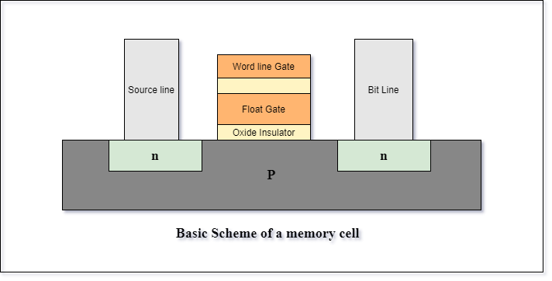

Figure 1 Basic Scheme of a semiconductor memory cell

This discovery has then led to two major discoveries based on the configuration involved:

1. Nand Memory: whereby the memory device is formed by parallel arrangement of semiconductor memory cells while
2. Nor Memory are formed by a serial arrangement of semiconductor memory cells

(Hyperstone, 2020)

In the current world as far as the current technology is concerned, there have been a lot of advancement of storage technologies. Since the early 2000s, as the microelectronics world rapidly changes from small scale integration to very large integration, the technology of storages has been simultaneously increasing toward higher scale of integration.

This increase in technology has allowed vasty increase in storage capacity over the time from several kilobytes that was stored in floppy disks and tapes to several Terabytes that can be stored in hard disks drives and solid-state drive.

Most of devices in the present time usually stores up to several gigabytes that can achieve up to 600 megabytes per second for reading and writing speed. These devices can be used for storage, data transfer or booting process.

Development of portable disk drives like USB flash drive, portable external hard disks and compact disks has been increasingly adopted over the years which lead to increasingly large number of flash disks in the market which does not satisfy the actual needs of the local market like compatibility, storage, costs and durability.

Furthermore, the increase adoption of the wireless radio communications protocols like Wi-Fi and Bluetooth has led to increase in reliability and flexibility to access data seamlessly over many applications like IoT systems, automation systems as well as industrial systems.

These wireless communications protocols have been used so far to transfer data and information over the internet and other subnetworks whereby some can even achieve up to 900 megabytes per second.

This project aims at reviewing and implement wireless storage system to the local market by using Nand memory since it is cheaper than the nor memory based on the research results done at the previous practical training.

The main stakeholders for this project are the local market of Tanzania.

## PROBLEM STATEMENT

"In the age of information and data storage, there's a growing demand for enhanced flexibility and seamless file sharing capabilities. While current solutions offer commendable features like high data transfer rates and security measures, there's an opportunity to innovate further.

As people’s demand continue to grow, we will only be able to meet their demands through developing a flexible, robust, and secure, wireless alternatives that priorities user friendliness interfaces and a strong data management. This entails developing solutions which not only provide simplicity and compatibility but also increase flexibility and security standards, so that individuals and businesses can enjoy a high quality of experience."

## OBJECTIVES

### Main objective

To enhance flexibility and security in wireless flash storage devices.

Specific Objectives

1. To enable reliable wireless data transfer: by enabling data transfer and access with both physical and wireless connections. In this term portability and convenience are considered.
2. To implement secure ways of data transfer: To implement robust security measures to ensure data is protected during transfer.
3. To implement multipoint user-friendly interfaces: To develop an intuitive and user-friendly interface that can cope with at least more than 3 operating systems with windows and Linux included.

## LITERATURE REVIEW

This project’s literature review is categorized based on the findings and topics. The classification is as follows

* Storage technologies:

1. Nand Memory technology: Based on the article published by Hyperstone on non-volatile memory, The author tries to explain theory behind the existence of NAND flash memory, characteristics, properties and different level of complexity they can achieve in term levels. (Hyperstone, 2020)
2. USB Mass storage server: in the article the author has successfully create and implement a smart usb flash drive using Raspberry Pi zero. The Pi zero acts as usb host and can be accessed wirelessly through SSH or Wi-Fi. The user can use these interfaces to manage files in the Pi zero. (Barnes, 2017)

* Wi-Fi technology:

From an article “For Wireless USB, the Future Starts Now”. The author has tried to explain the emergency of wireless USB which can be implemented over the internet. This rising technology implements the use of current advancement of radio communication and Wi-Fi protocol as the major tools. He also explained different protocols such as UWB, WUSB and CWUSB.

By utilizing the full spectrum, UWB can achieve superior performance while consuming less energy. Essentially, UWB achieves bandwidth by using low-energy pulses across a wide frequency range. The majority of other wireless technologies accomplish performance at the expense of excessive energy consumption since they only use one designated band within a frequency spectrum. (IEEE, 2007)

* Interface used:

1. This design aimed at implementing a storage device that can be accessed wirelessly though acting as a normal USB disk. The design is comprised of two separates modules, the adapter module for the interface to the PC and the storage module, which is made up of the flash memory, chip to be used as a mass storage device. These modules communicate wirelessly for as near as two meters. In this design there is no middleware needed for file transfer. Since the USB module act as a dongle, the computer treats the whole system a separate usb flash drive. (Czapor, Hartney , & Knight , 2006)
2. On another article presenting Sandisk Connect in which the designer has used middleware to transfer data across different operating system. Sandisk wireless pen drive can transfer data in both physical channel through USB and wireless channel through Wi-Fi interfaced to specified Sandisk software for file transfer. Although the product has now been in production decline since 2022 (Digital, 2022)

## REQUIREMENT GATHERING

This is an innovative solution that raised as the challenges to transfer data arises. This process involved the use of initial data of questionnaire to perform the required gathering performed to a small community in Dar es Salaam.

In the prepared questionnaire the following questions were asked and only the population of 28 people responded as follows.

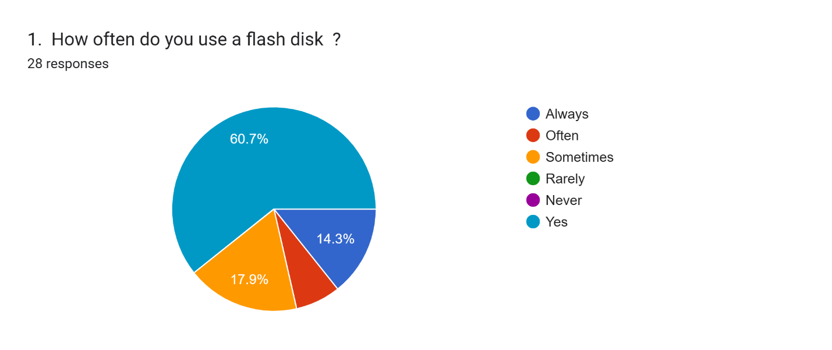

People are using the usb flash drive hence there is a high demand.

Forms response chart. Question title: 2. What size of storage will best suit your needs?
. Number of responses: 28 responses.

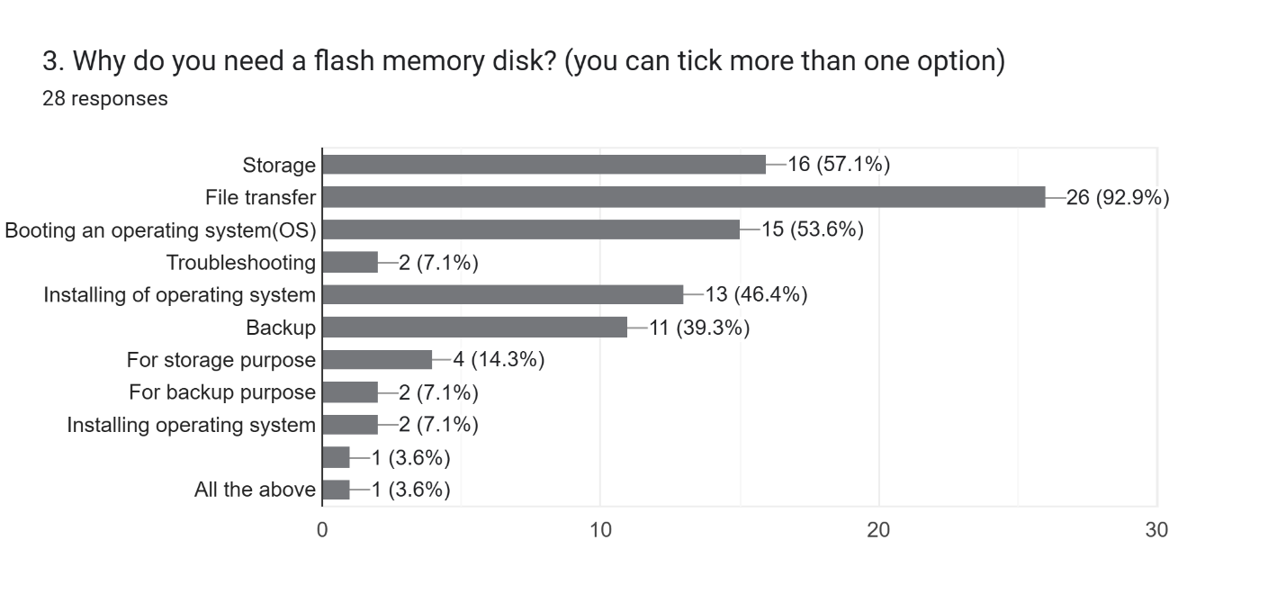

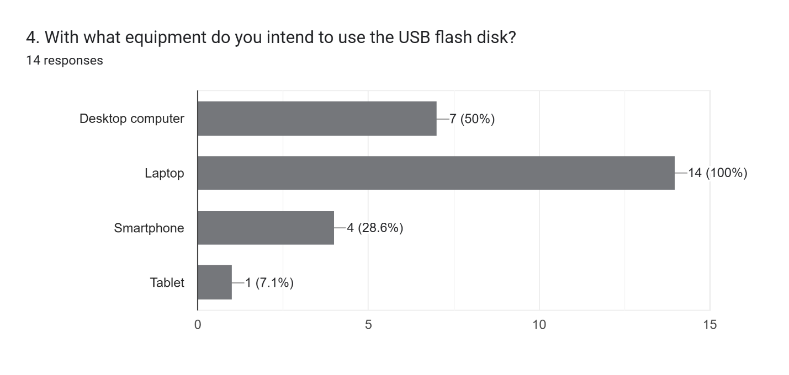

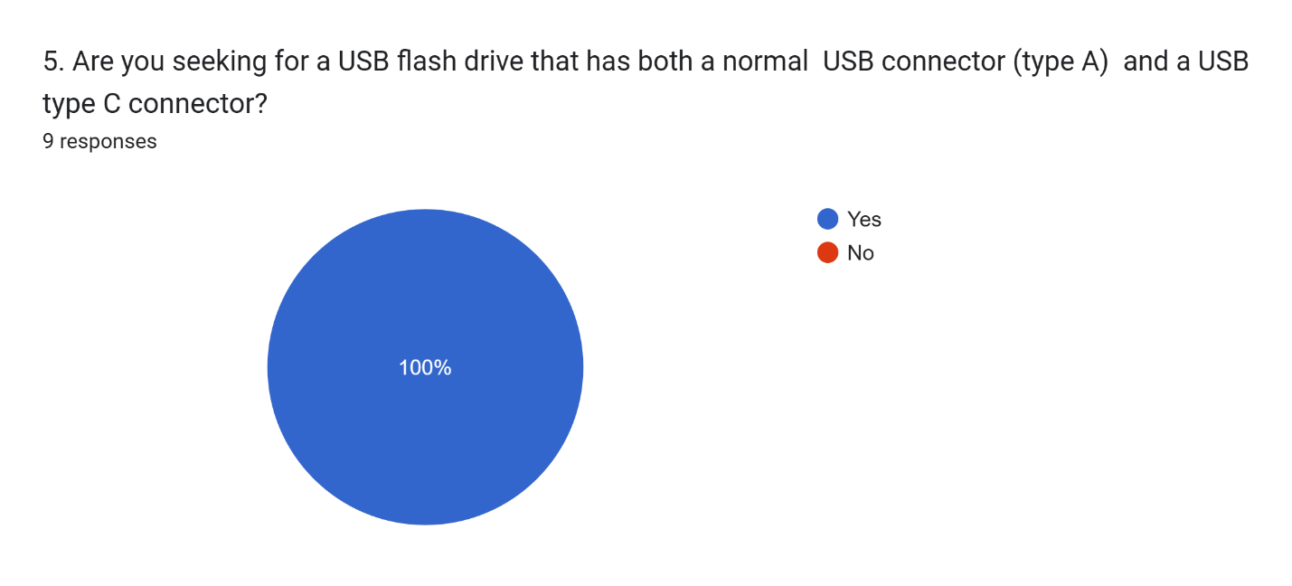

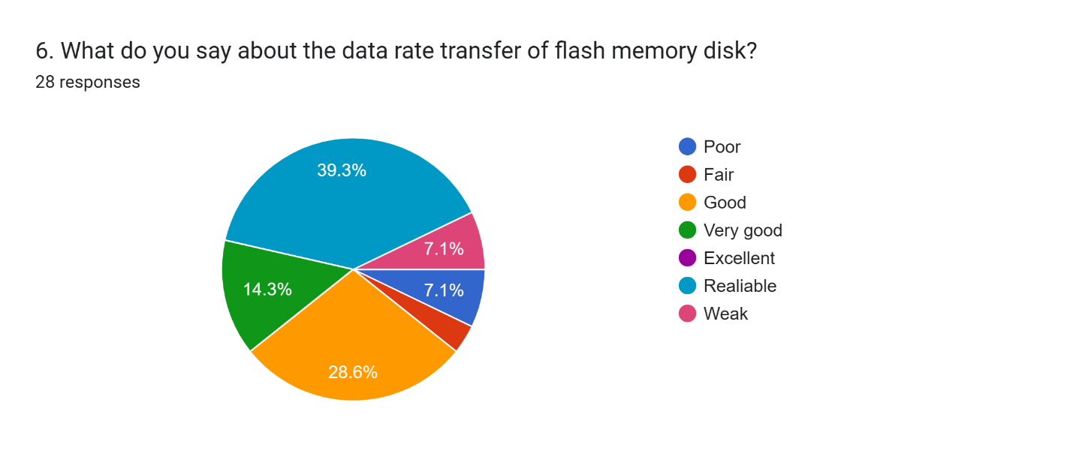

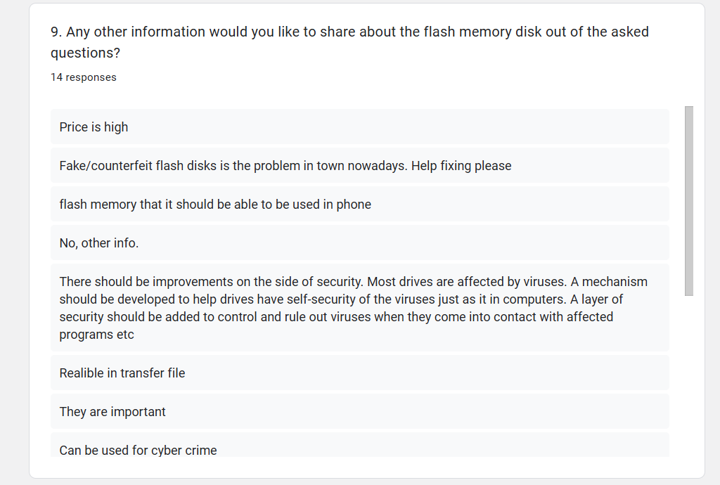

By using the data from above analysis, the following general demands can be deduced

1. Customer need faster usb devices
2. Customer need a more flexible and more ways of data transfer
3. Customer need to be able to share files in all his/her devices.
4. Customer need a more reliable and secured flash drive
5. Customer need a larger storage.

## METHODOLOGY

This project will follow the water-fall methodology whereas the bottom-up approach will be used to achieve the main objective. This system combines and adopts the works of other successfully works as sub modules or components responsible to accomplish a certain functionality which is then integrated to one system. The following are the key points that will be implemented to accomplish main objective of this project:

* To implementing mass storage server using the normal physical connection that is usb which will provide a user with choices that mostly fits comfortability. This is done by finishing up and utilize the existing design of flash disk drive that uses USB connector that was done as practical training III year 2023 that was done by myself with my colleague Neria I Rutashobya with registration number 2020-04-10739 as the base design for this project

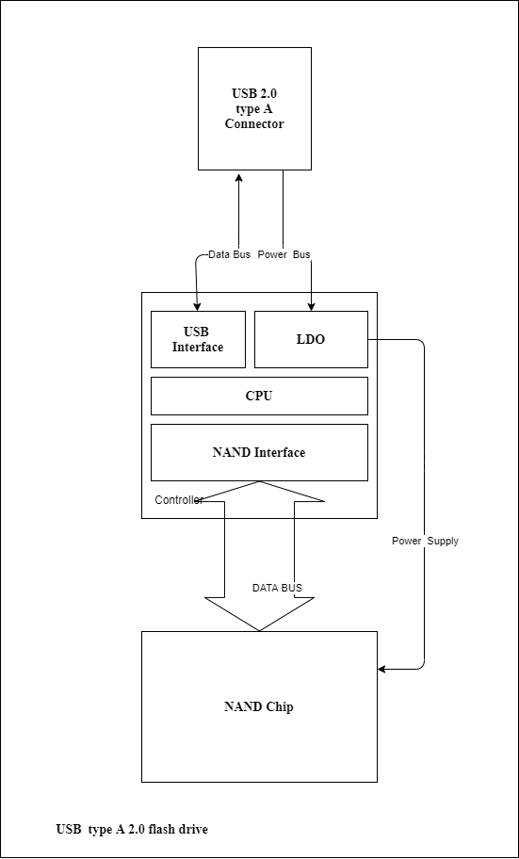

Figure 2 A typical USB Flash Drive

* To develop or utilizing the existing ways of creating a local area network wirelessly between the Host and the Client that involves the user with less handshaking process.
* To develop a robust way of data transfer between the host and the client which include using more than one data channels, modified session database to always remember session whenever there is a fluctuation/loss in connectivity.
* By utilizing the existing encryption technologies such as hybrid encryption technology which utilizes both symmetric and asymmetric encryption technology. A secured and a robust yet reliable system can be developed.
* By implement the in-built features for wireless file transfer that already exist in most of the operating systems like samba (SMB) protocol and network file sharing (NFS) protocol to reduce congestion of procedure that the user is supposed to consider in order to perform data transfer.
* By implementing a user-friendly encasing design, can provide user with a comfortability and enhanced mobility.

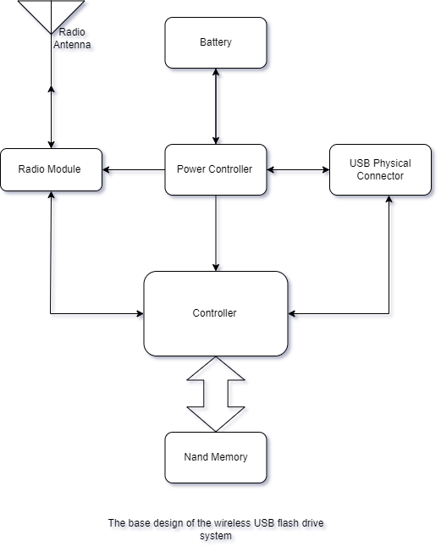

### Concept generation

This subsection provides an overview on how the devices and equipment selection to be used to establish the Wi-Fi enabled flash drive as a system.

There are two methods used to perform concept generation for usb wireless flash drive:

1. Concept Table
2. Concept Fan

From the device block diagram below,

This system is divided into mainly 5 subsystems

1. Usb interface (25%)
2. Wireless server (40%)
3. Controller (20%)
4. Non-volatile memory (10%)
5. Power system (5%)

|  |  |  |
| --- | --- | --- |
| **Part** | **Prerequisite** | **Available raw options** |
| Controller | * More than 3 threads, * Low power management, * Optimized subsystems * More than 20 gpio * High library community | SAMD series,  PIC series,  STM32 series,  Esp32 series, |
| Power System | * Can last more than 24 hours, * rechargeable. | Solar panel, Usb port, Rechargeable battery like lithium-ion, |
| Non-volatile Memory | * Interface: SPI || NAND || eMMC | Micron Nand Memory,  Samsung Nand Memory, eMMC cards, Samsung UFS flash memories. |
| * Storage :> 8GByte |
| Wireless server | * More than 50 Mbytes per second achievable transfer speed * Wi-Fi and Bluetooth connectivity * File transfer Server. | Web Server, Software as middleware, Bluetooth, Wi-Fi  Network Attached Server (NAS). |
| Usb interface | * Usb capability version > 2.0 | Usb type A, B or C |

#### Available Options for Each Subsystem.

Categorization of parts for available options:

1. **Wireless Server (40%)**

This is the combination of hardware and software programing with specific protocol in order to achieve wireless file transfer protocol. According to findings in [1] there several protocols that can be programmed into a controller and be used to provide file transfer service:

* + 1. **Network file sharing (NFS) protocol**: Mostly used in Microsoft computers for file sharing. The fastest of all below protocols.
    2. **Server Message Block (SMB or Samba Server):** used in all major three operating systems that is Windows, MacOS and Linux. Suitable for multiplatform compatibility.
    3. **Internet Small Computer Interface (iSCi protocol):** Old but strong protocol that was used in early development of operating system to transfer and manage files. It is still used in some architectures for file transfer. It is used to manage raw data in disk like backups and virtual machines.
    4. **Apple file protocol**: Used in MacOS devices to perform file transfer to other macOS supported devices with higher performance than SMB protocol.

Concept Table for wireless Server

Likert scale to be used: -

1 - very poor, 2 – Poor,3 - Acceptable,4 – Good,5 - Very good.

|  |  |  |  |  |  |  |  |
| --- | --- | --- | --- | --- | --- | --- | --- |
| Protocol | Flexibility | Multiplatform  Compatibility | Speed | Security | Portability | Robustness | Total |
| NFS | 2 | 1 | 4 | 4 | 1 | 3 | 17 |
| SMB | 4 | 4 | 3 | 4 | 3 | 4 | 22 |
| iSCi | 2 | 5 | 3 | 1 | 5 | 2 | 18 |
| Apple File Protocol | 1 | 1 | 3 | 3 | 2 | 2 | 11 |

Therefore, the protocol with the highest preference is Samba protocol followed by iSCi and NFS

1. **Usb interface (25%)**

This is the interface used by most advanced computerized systems and edge consumer devices. It involves the communication of two or more devices with using differential pair of wires.

There are several usb generations each precedeng the other with higher datarate. Mainly are

* + 1. Usb 1.1 achieving up to 12Mbps
    2. Usb 2.0 achieving up to 500Mbps
    3. Usb 3.0 achieving up to 5Gbps



Concept Table for Usb Interface

Likert Scale used: -

1 - very poor, 2 - Poor, 3 - Acceptable, 4 - Good, 5 - Very good.

|  |  |  |  |  |  |
| --- | --- | --- | --- | --- | --- |
| **Usb generation** | **Speed** | **Cost** | **Compatibility** | **Flexibility** | **Total** |
| 1.1 | 2 | 4 | 3 | 3 | **12** |
| 2.0 | 3 | 4 | 3 | 4 | **13** |
| 3.0 | 4 | 3 | 2 | 4 | **12** |

Therefore, with difference in cost and flexibility usb 2.0 is choosen.

1. **Non-volatile Memory (5%)**

Since this project is adopting the project done in the practical training 3 2022/23 of developing a local consumer based usb flash drive which used a non-volatile Micron Nand memory MT29F64G08 for data storage.

1. **Power system (5%)**

For better performance and affordability, better requirement of power storage and source will be duscussed as the effect of the established system.

Power Rating of the established system will therefore later be used to construct a desired goal which aimed for this device to support for file transfer for more than 24 hours.

1. **Controller (25%)**

Controllers can be categorized using concept fan as follows

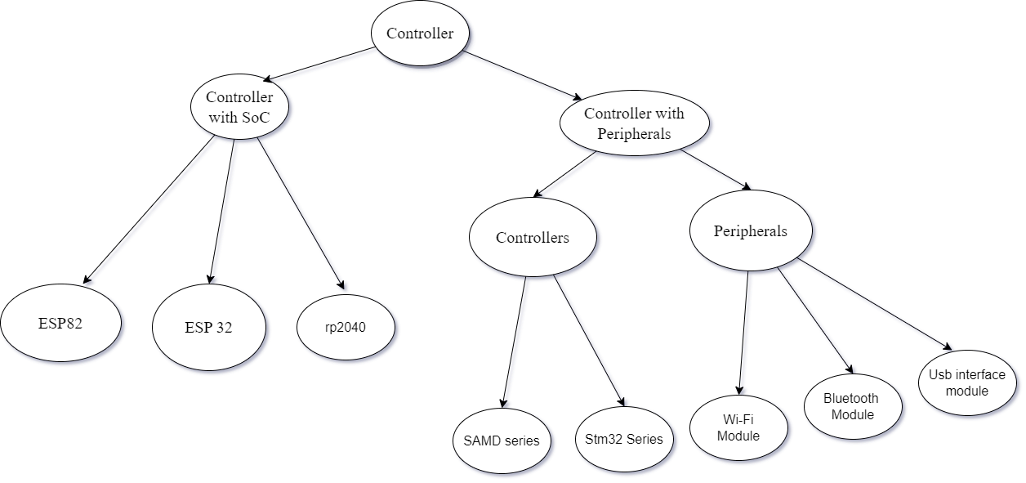

Figure 3 Concept fan for available Controller options

One advantage of controller with system on chip (SoC) architecture over controller with peripheral is that it save power, space, cost and time.

Therefore, Controller with system on chip(SoC) preceedes those with peripherals.

Classification of SoC controller using specification table:

|  |  |  |  |  |  |
| --- | --- | --- | --- | --- | --- |
| **Chip Series** | **Cores** | **Supported Subsystems** | **Clock frequency** | **RAM/ROM** | **General Purpose pin** |
| Esp 82 | 1 32-bit RISC-V CPU | Wi-Fi,SHA-256, AES,SPI,I2C,CAN,Wire,ADC, PWM,UART, ETHERNET | 80MHz | 64 KB/4 MB | 17 |
| Esp 32 | 1,2 32-bit RISC-V CPU | Wi-Fi,SHA-256, AES, SPI, BLE, RTOS, ZigBee, Touch Sensor,ADC,CAN,Wire,PWM,UART, ETHERNET | 80MHz – 240MHz | 520 KB- 16 MB/ 338 KB -16 MB | 34 - 45 |
| Rp2040 | 2 Cortex(M0+) | SHA-256, AES,SPI,I2C,CAN,Wire,ADC, PWM,UART,ETHERNET | 133MHz | 260 KB/2 MB | 30 |

Here, Esp32 preceeds other microcontrollers in term of architecture, storage, amount of supported subsystems and cpu frequency.

#### CHOISE OF CONTROLLER: ESP32 VARIABLES

Based on the initial requirement specification of controller for secured wireless Usb flash drive that are:

* + More than 3 threads,
  + Low power management,
  + Optimized subsystems,
  + More than 20 gpio,
  + High library community,

By using esp product selector with link : [https://products.espressif.com/#/product-selector?names=](https://products.espressif.com/%23/product-selector?names=) . It was easy to select appropriate controller module for this project.

Here is a comparison between different versions of esp32

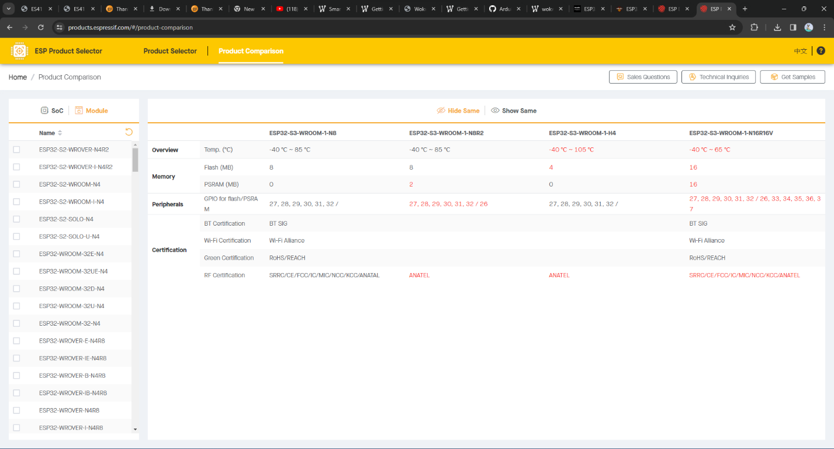

Figure 4 Difference between ESP32-S3-WROOM-1-N8, ESP32-S3-WROOM-1-N8R2, ESP32-S3-WROOM-1-H4 and ESP32-S3-WROOM-1-N16R16V.

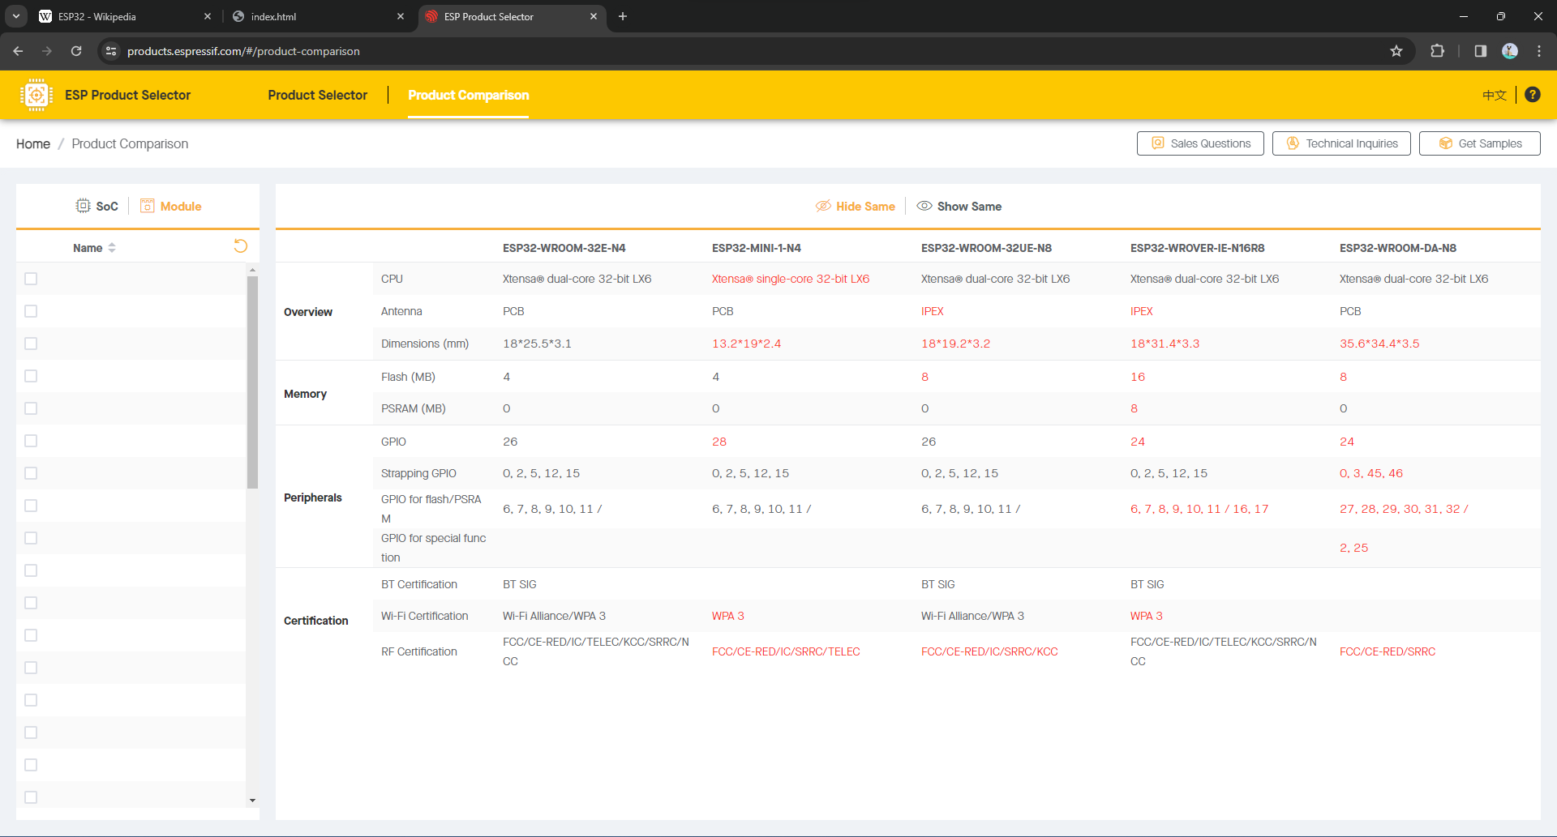

Figure 5 Difference between ESP32-S3-WROOM-32E-N4, ESP32-S3-WROOM-MINI-1-N4, ESP32-S3-WROOM-32UE-N8 and ESP32-S3-WROVER-IE-N16R8, ESP32-WROOM-DA-N8.

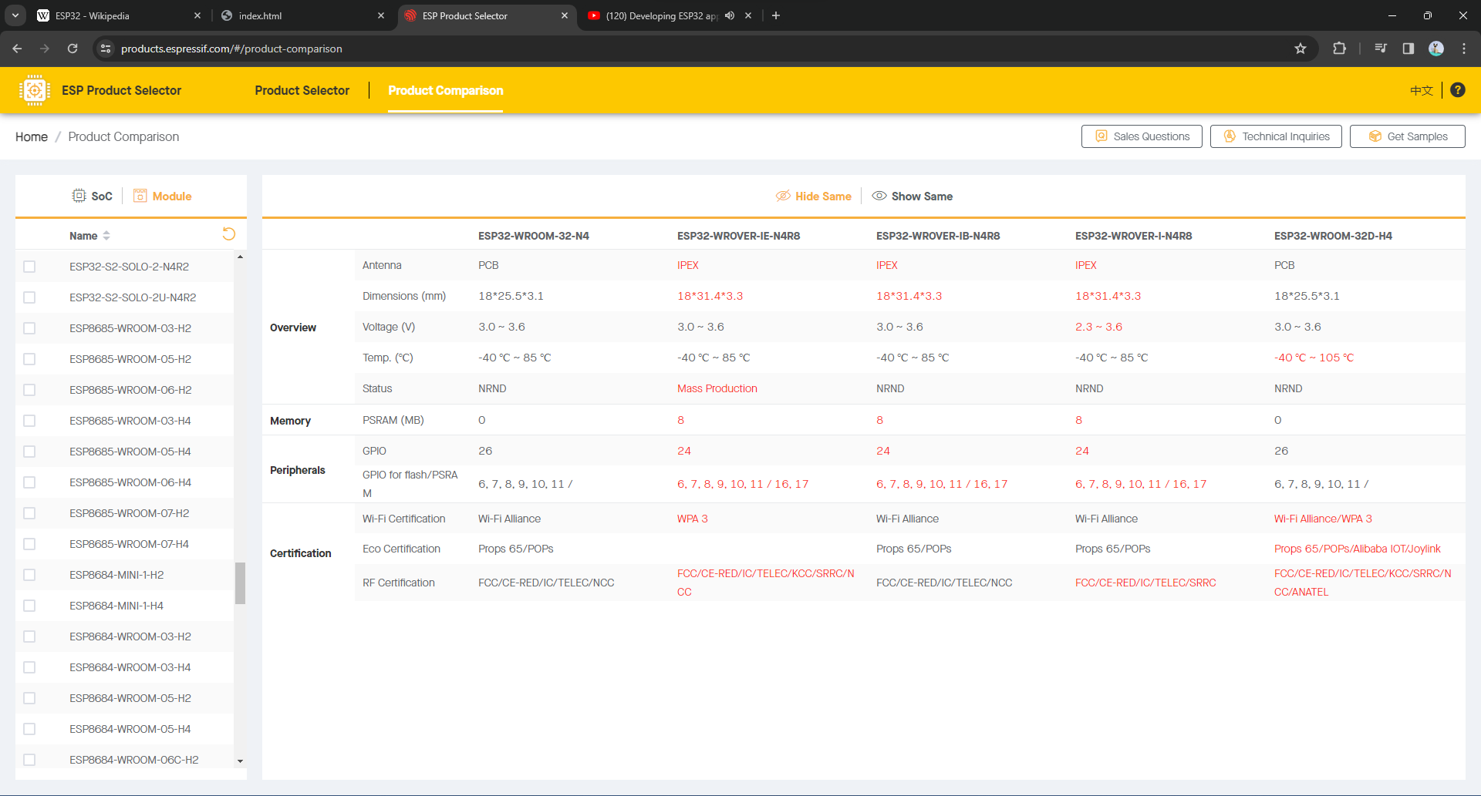

Figure 6 Difference between ESP32-S3-WROOM-32-N4, ESP32-S3-WROVER-IE-N4R8, ESP32-S3-WROVER-IB-N4R8, ESP32-S3-WROVER-I-N4R8 and ESP32-S3-WROOM-32D-N4.

Therefore, for mass-production, ESP32-WROVER-IE-N4R8 seems to fit the required objectives with

* 1. Xtensa@ dual core – 32bit LX6,
  2. Power supply of 3.0 – 3.6 voltage,
  3. Wi-Fi and Bluetooth Low Energy capability,
  4. 4 MB secondary memory,
  5. 8 MB of pseudo random access memory suitable for file transfer service,
  6. Large Esspressif community,
  7. Integrated Development Environment for project development support,
  8. Ultra low power consumption with sleep mode up to 4mA,

### Flowchart

The projects main process will be implemented through the following trends of processes

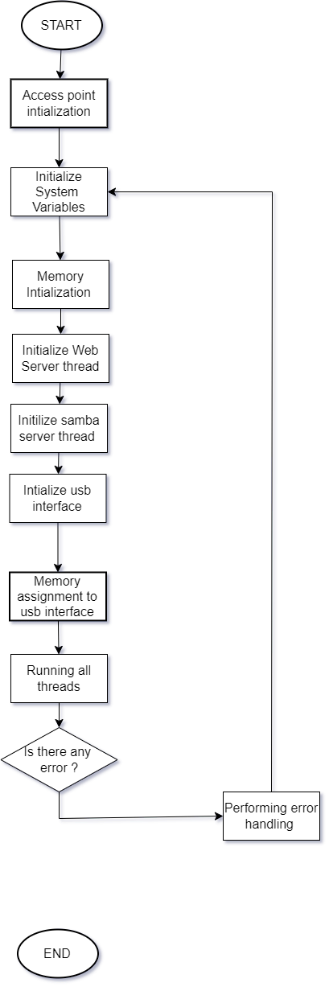

Figure 7 The main program workflow

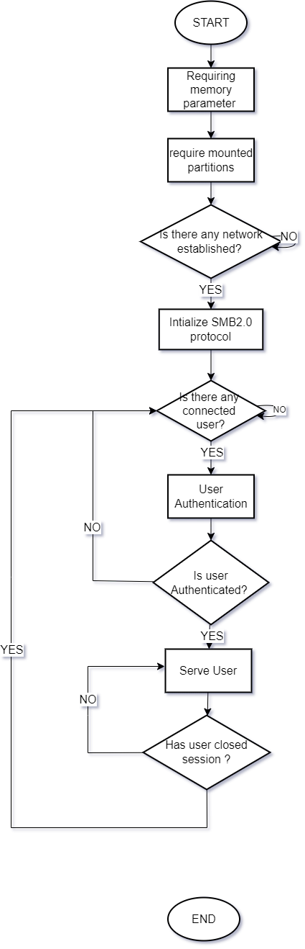

Figure 8. Samba Server Flowchart

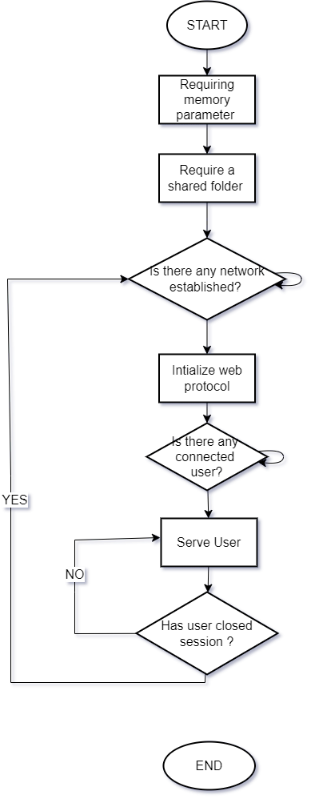

Figure 9. Web Server Flowchart

### Use Case

The diagram below shows on how the user events and processes are initiated and completed in order to achieve the main goal of this project

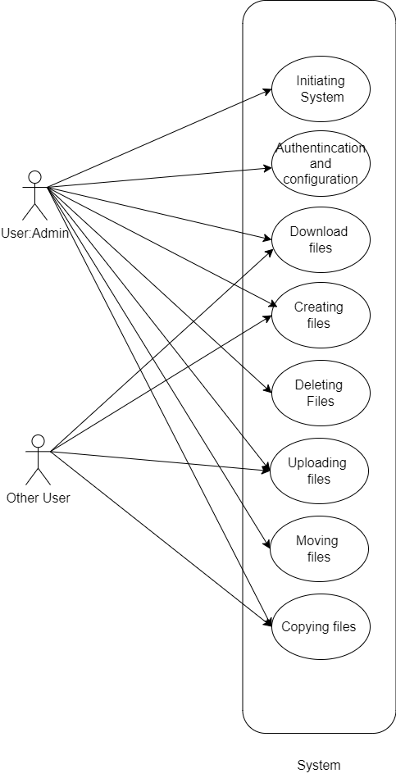

Figure 10. Use Case

### Relation Diagram

In this project there are three important classes which needs to be implemented that is server, storage, and users.

NOTE: The system allows the user to transfer data as an admin and can have an access to all files if he/she uses usb port to connect to the end devices. Hence, no security is granted to the personal data when the driver is possessed by other individual or lost.

The diagram below shows the relation between each class.

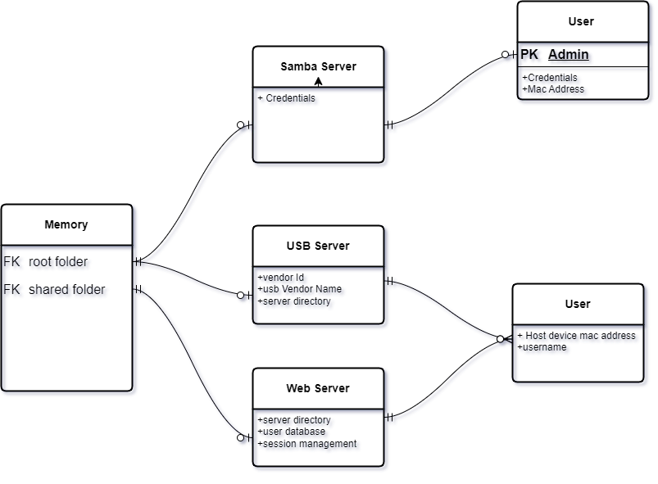

Figure 11. Entity relation diagram

### Sequence Diagram

After definition of the above flow of procedure the sequence diagram between the user and device can be figured as follows

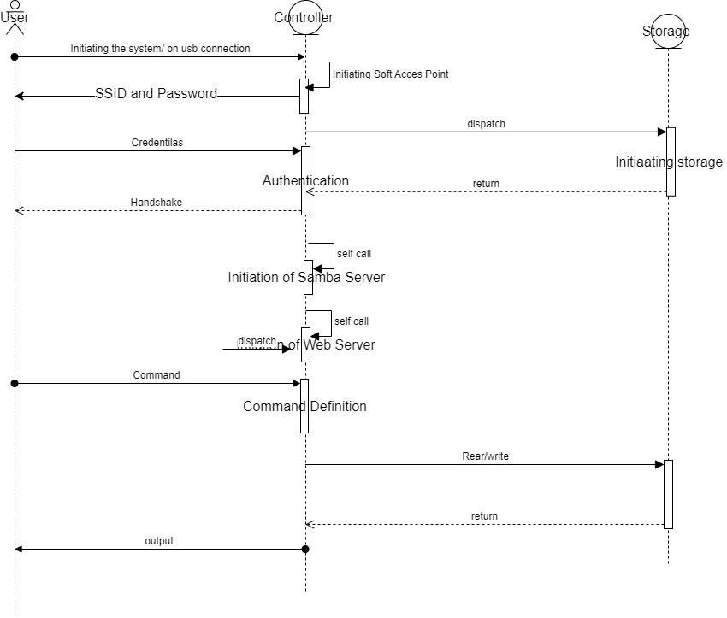

Figure 12. Sequence diagram

## EXPERIMENTATION

These experimentations involved the use of different workspaces to achieve different requirements. This method involved systematic preparation of Wi-Fi-enabled secured wireless USB flash drive by utilizing tools and utility like internet, libraries and documentations that could help the achievement of this project’s objectives. Due to incomplete and unachievable goals for the memory disk and complexity of the usb protocol. The system required to perform several try and errors. Throughout the journey, in each trial and error the following were performed

1. Conception:

The innovative ideas were revised and modified with respect to the required needs.

1. Design:

The ideas were refined and modified to some electrical engineering theories to produce a working circuit. Which is then used to produce schematics for the usb flash drive

1. Programming and testing:

This part involves the documenting and referencing where by the available community provided with some of the solutions for raising problems. Most of the parts, programming was performed from the scratch including parallel NAND flash interfacing which includes its own protocol, Wi-Fi for enterprise level and web file server interfacing.

1. Observation:

Details of the input and output were taken to analyze the performance of the system.

1. Optimization:

This is done to improve the results and performance.

The following are the list of experiments done to accomplish the objectives of this endeavor.

### Usb flash drive initial design

This is the initial trial and error which includes the use of manufactured microcontroller CBM2096 and 64GigaBits NAND storage chip produced by micron technology MT29F64G08ABACA with which was equipped with different versions like 16Gigabits storage and 8Gigabits storage

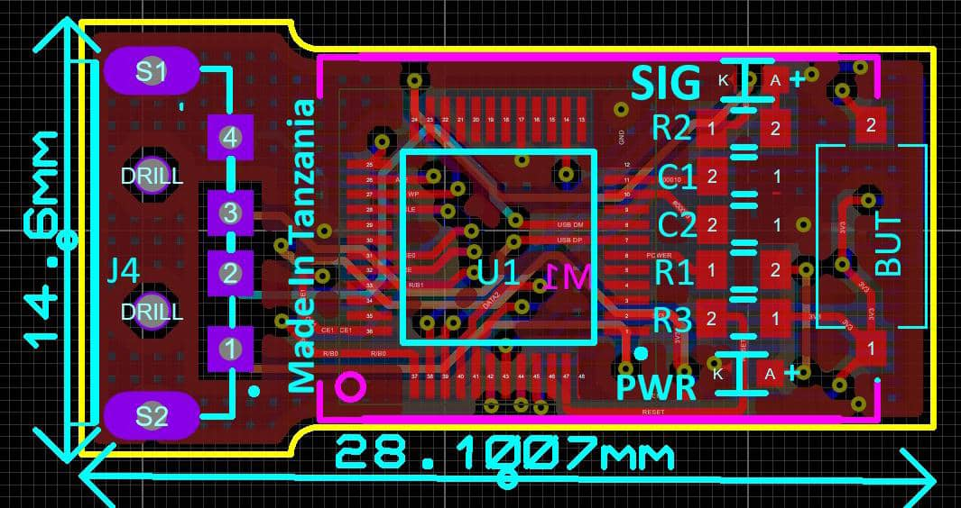

Figure 13. The initial design of usb flash drive

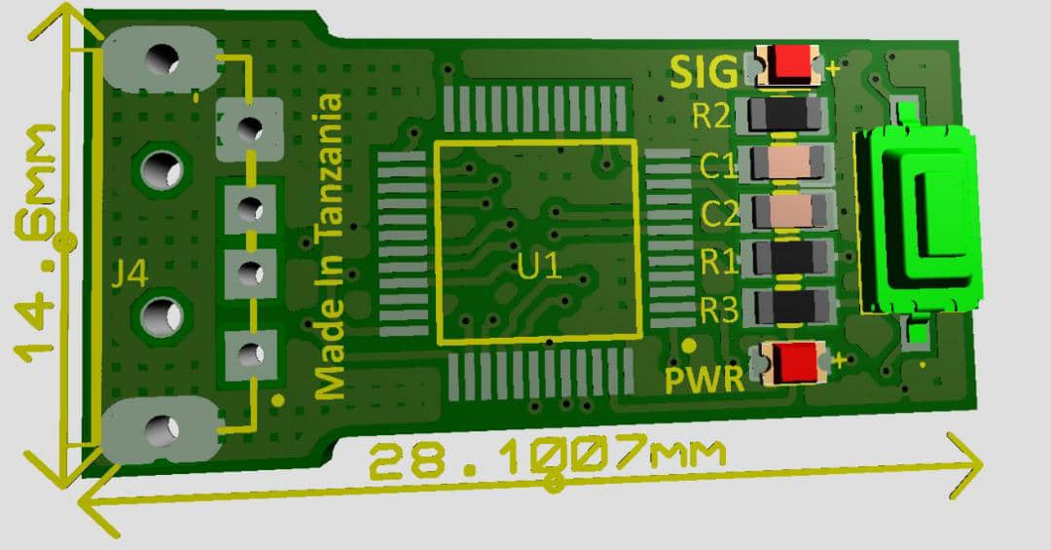

Figure 14. 3D view of the initial design

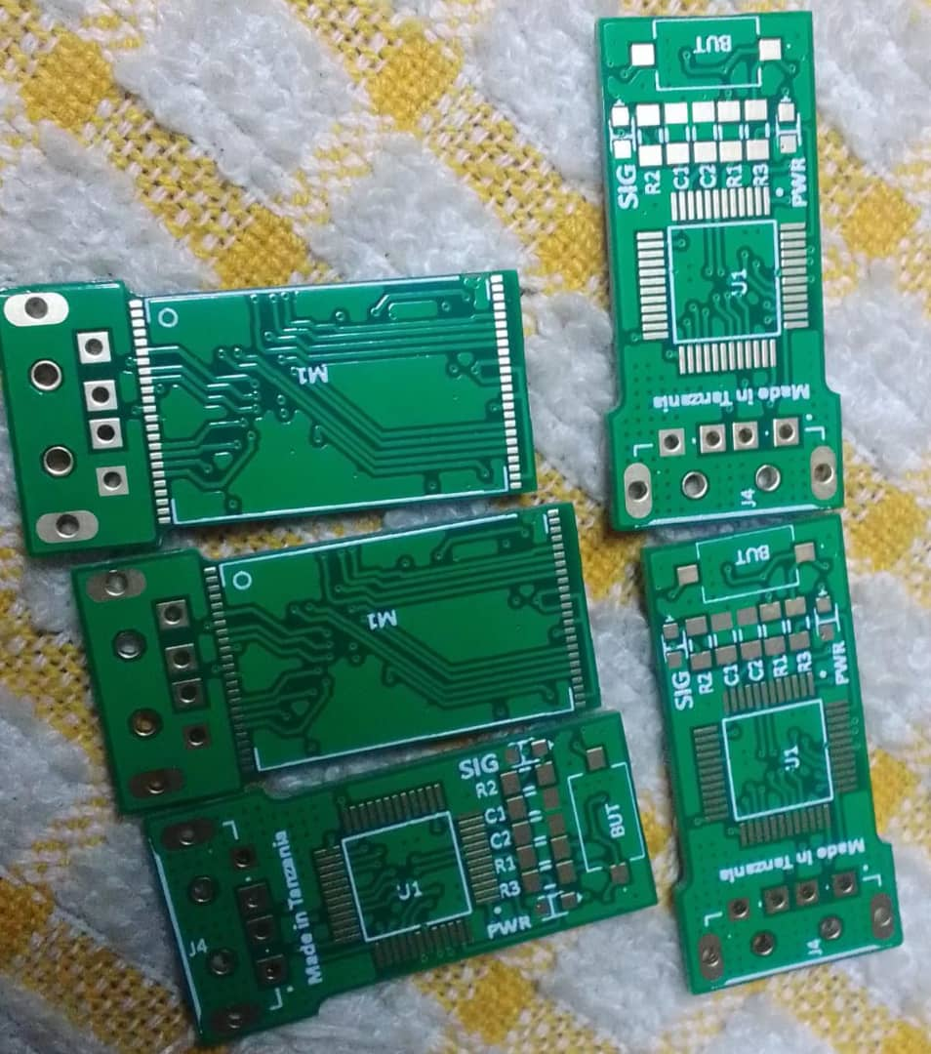

Figure 15. Manufactured PCB Boards for the initial design

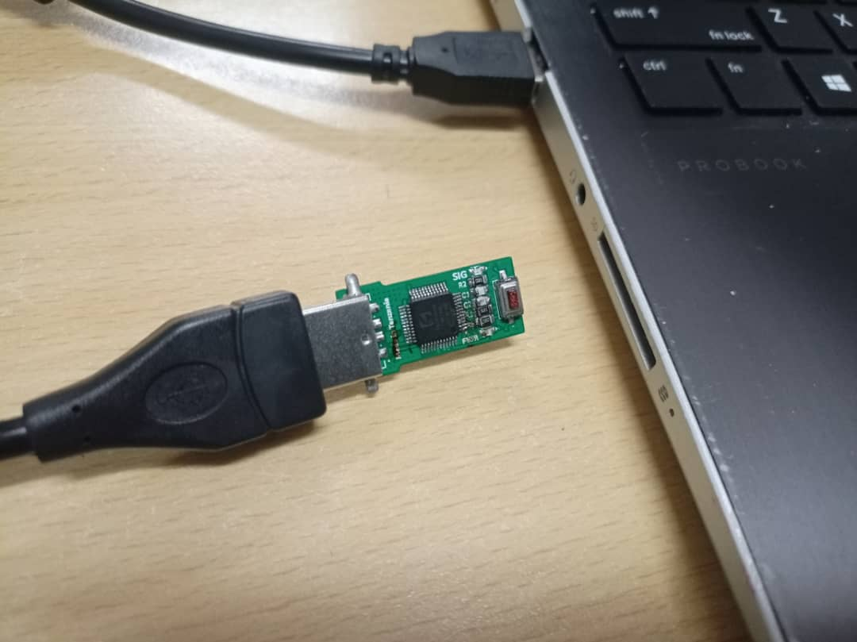

Figure 16. Testing of the initial board

Testing of the initial board resulted into incompatible chip type CBM2096P instead of CBM2096 which required an additional external oscillator crystal to run which was not in the first design.

Observation:

The NAND memory required high level of timing handling.

The chip CBM2096 is not open source hence hard to troubleshoot.

There was a very small community of producers of flash storage solutions.

The flash ended up only detected by computer as a storage with four megabyte of storage which was out of the required expectations.

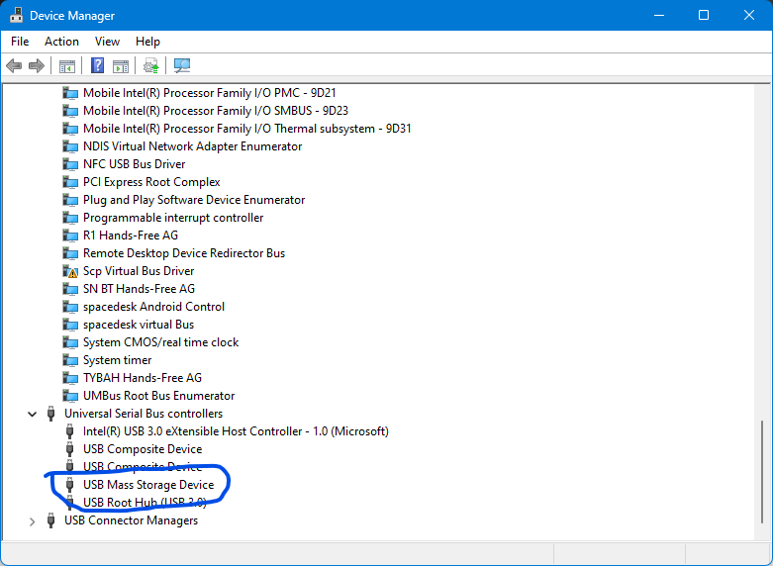

Figure 17. Usb detected as Mass storage Device

### Web interface Simulation

In this part, the simulation was performed on wokwi and then due to the limited resources could not simulate any further.

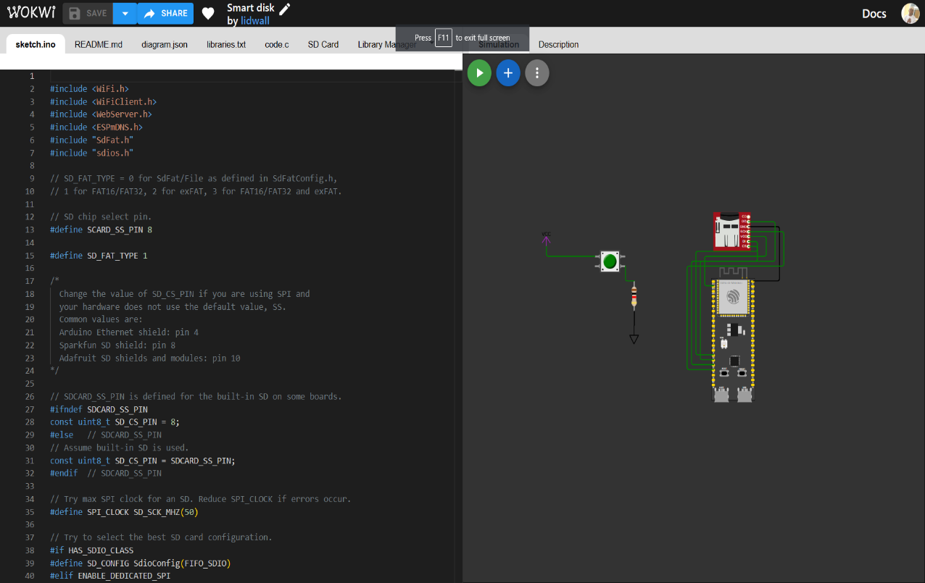

Figure 18. Simulation on wokwi. SD card is used in place of Nand Flash memory to demonstrate non-volatile file storage.

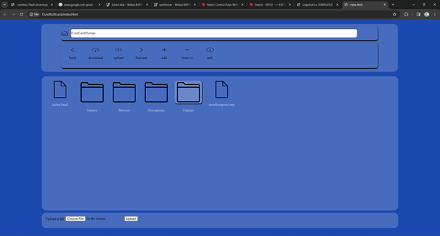

Figure 19.Interactive Web file server as output after simulation

Observation:

1. So easy to program and use.
2. It has had a large library hence it is easy to troubleshoot and debug a problem
3. Wi-Fi features was enabled but there was no Wi-Fi interactivity
4. No Nand memory device was available.
5. Requires internet access always.
6. Due to limited interactions, I couldn’t observe my progress.

### Locally programmed usb flash drive with wireless features

The locally programmed Wi-Fi-enabled usb flash drive is featured with the following

1. Usb Mass Storage class capability 2.0
2. Wi-Fi capability
3. Mass storage Capability enabled by Nand Memory
4. ESP32S3N16R8 dual core System on Chip SOC microcontroller.
5. ESP-IDF using ARDUINO IDE.
6. Wi-Fi Access point capability
7. No display
8. Rather Wi-Fi Captive portal for status update.

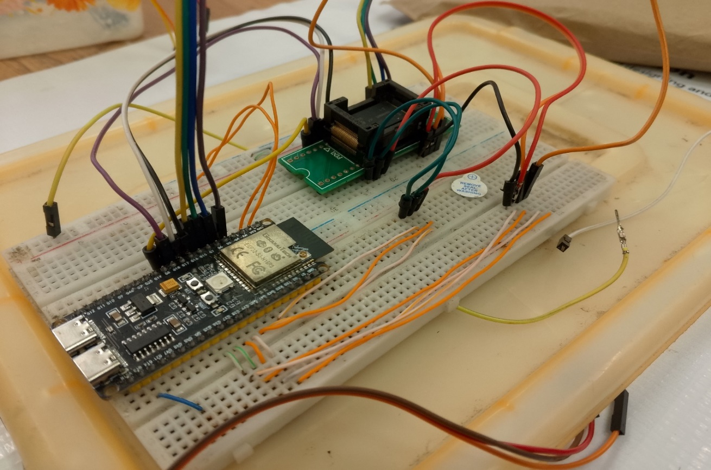

Figure 20.Experimenting NAND memory on the board

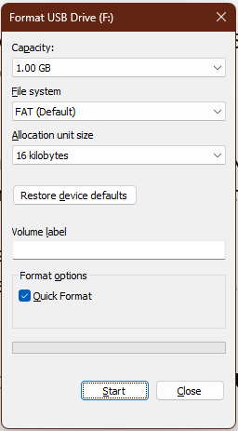

Figure 21.Experimented circuit is visible as a usable flash ready to format for general uses

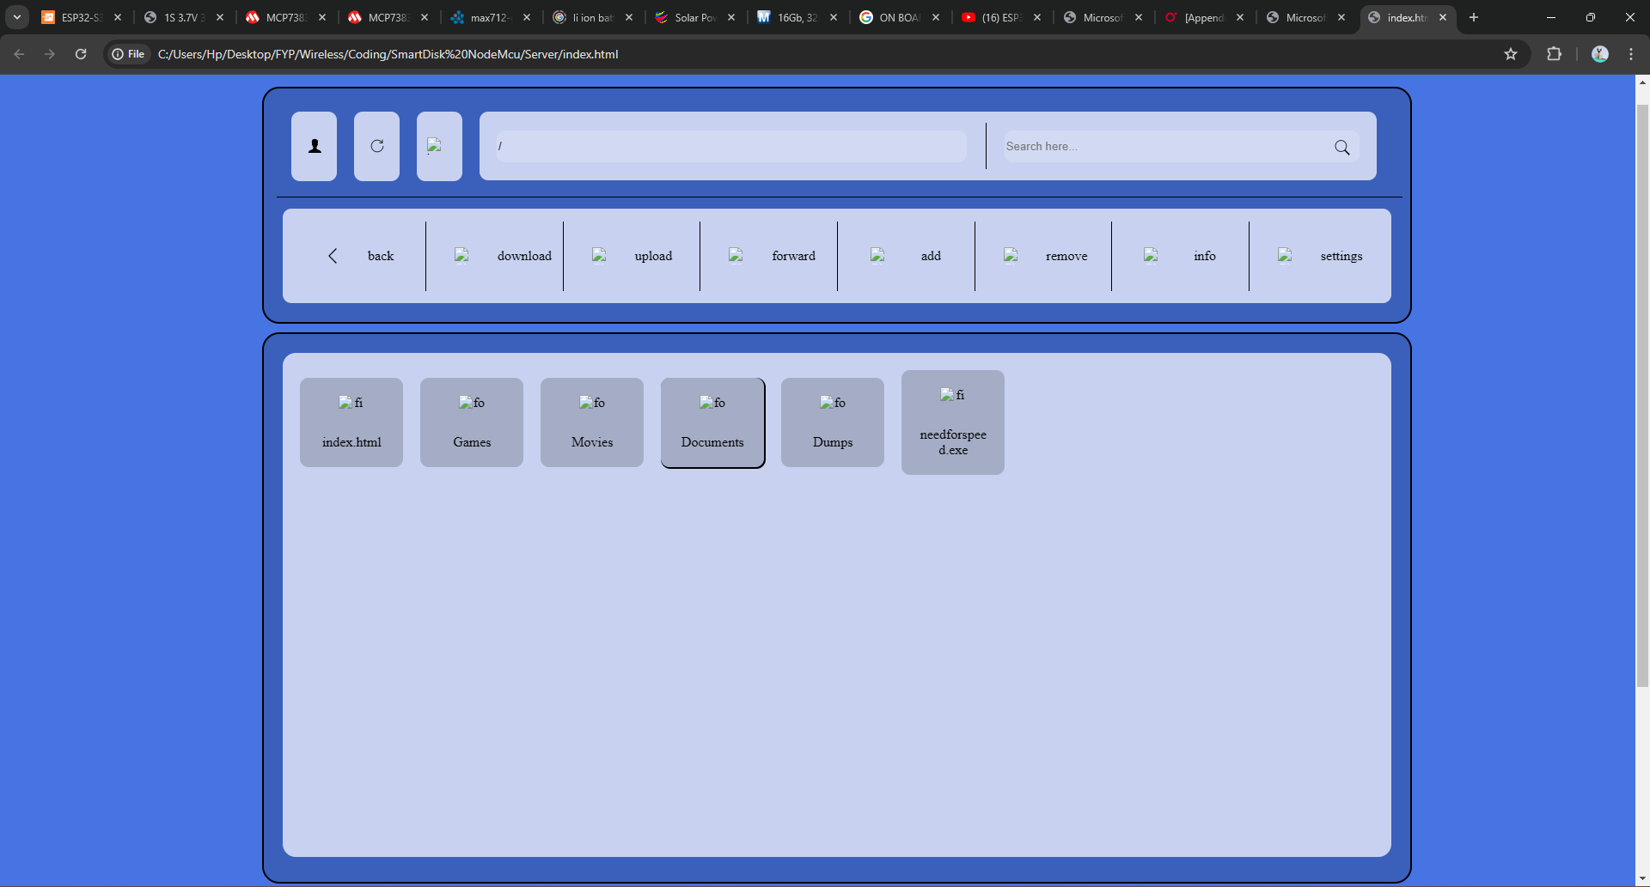

Figure 22. Once connected, the user is automatically redirected to this page connected to this device’s Wi-Fi. Like TTCL-WIFI 2 and WIFI 4U.

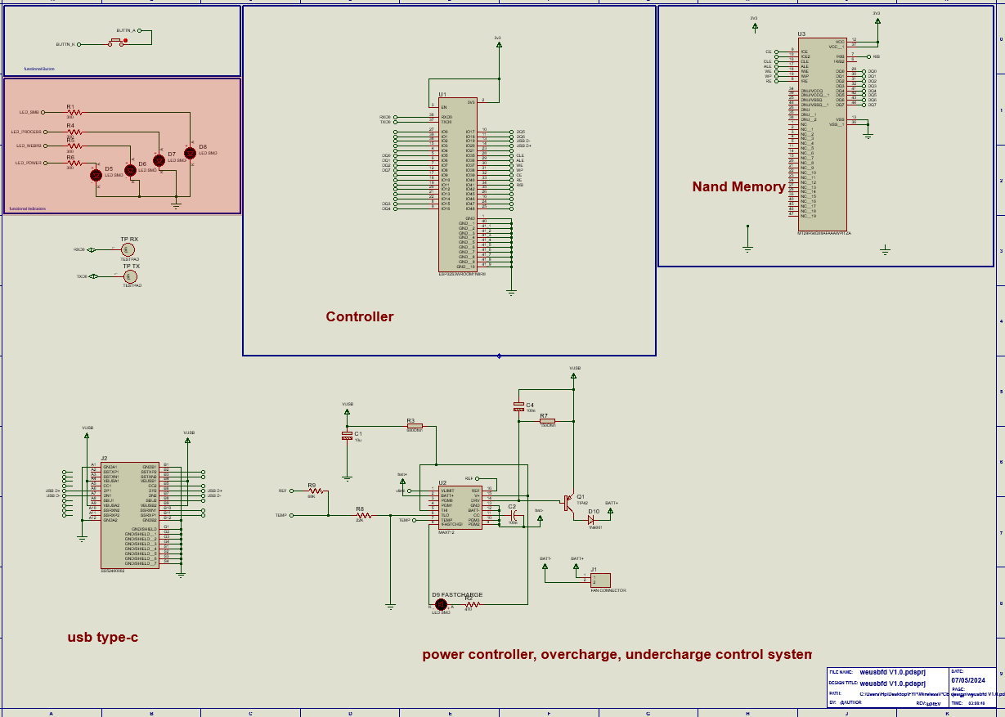

Figure 23. Schematic design of the prepared circuit

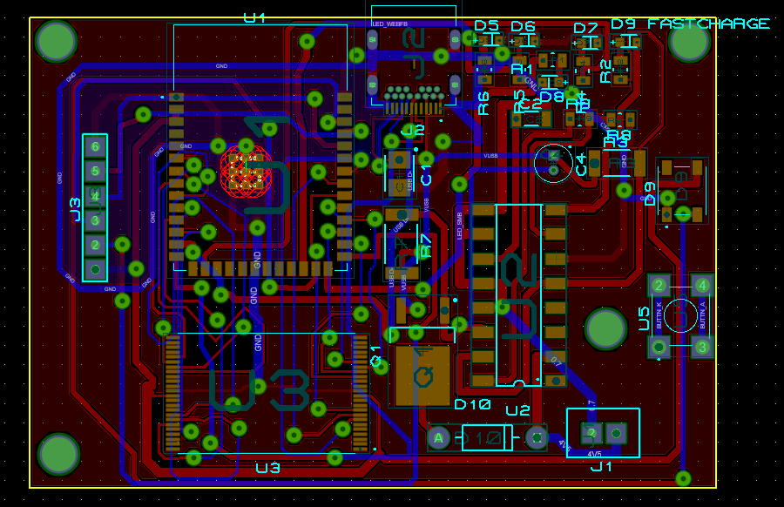

Figure 24. PCB layout of the prototype

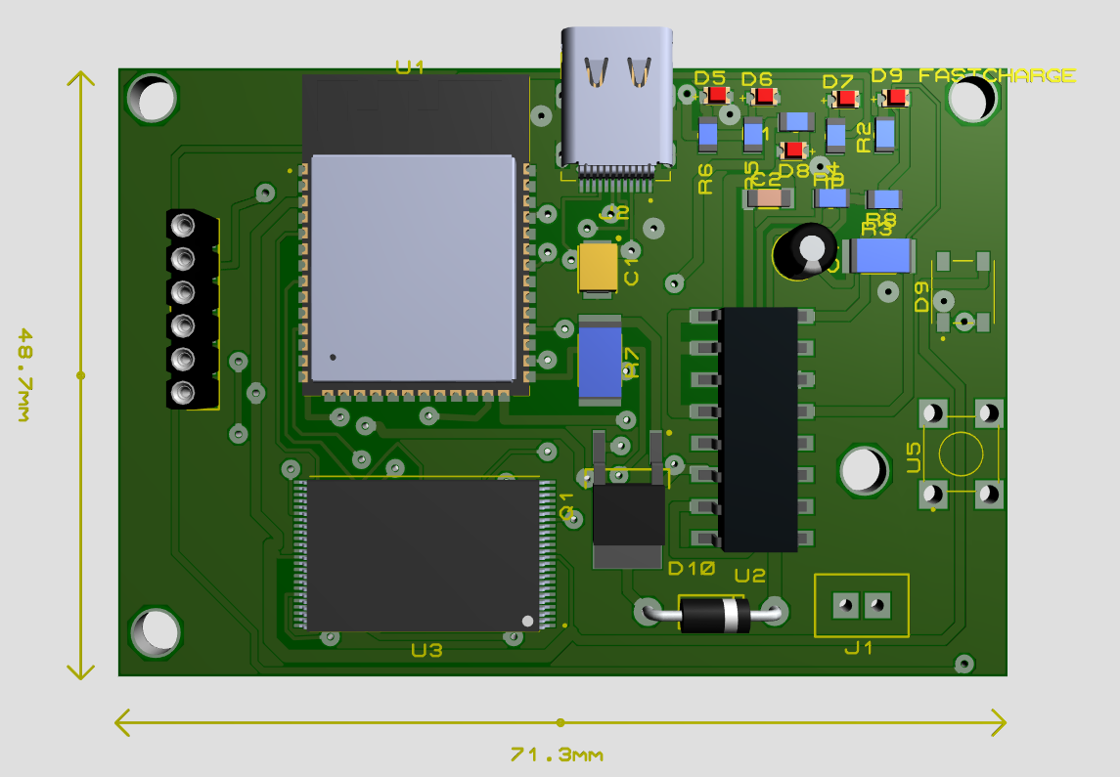

Figure 25. 3D layout of the prototype of WEUSBFD

Observation:

* 1. The use of Nand storage device could only produce maximum speed of 4.7kps

Conclusion:

Since, the design could not meet the requirement to be manufactured, the designed layout was optimized and left pending for time saving.

### Locally Manufactured design of WEUSBFD

This design featured the following

* + - 1. Usb Mass Storage class capability 2.0.
      2. Wi-Fi capability.
      3. Mass storage Capability enabled by SD CARD/SD_MMC.
      4. ESP32S3N16R8 dual core System on Chip SOC microcontroller.
      5. ESP-IDF using ARDUINO IDE.
      6. Wi-Fi Access point capability.
      7. Wi-Fi Captive portal for status update.
      8. Locally manufacturing of PCB.

In this design the main changes were made compensate the following

* + 1. Nand storage read was slow hence changed to SD_MMC which influenced reading speed up to 10MBps
    2. Could not afford PCB manufacturing for remaining time frame.

.

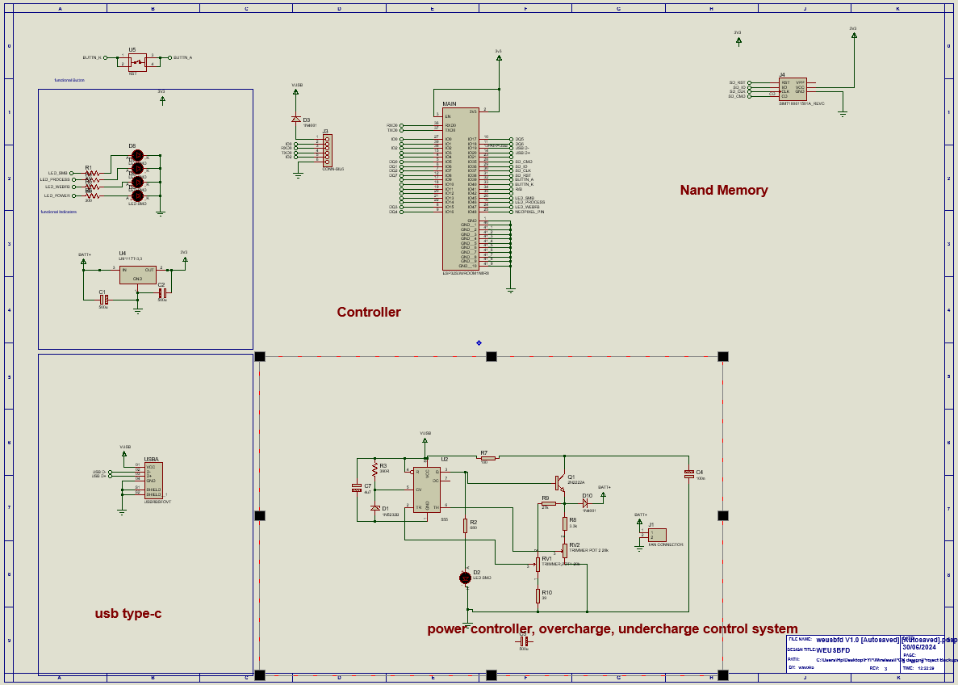

Figure 26. The final design schematic layout WEUSBFD

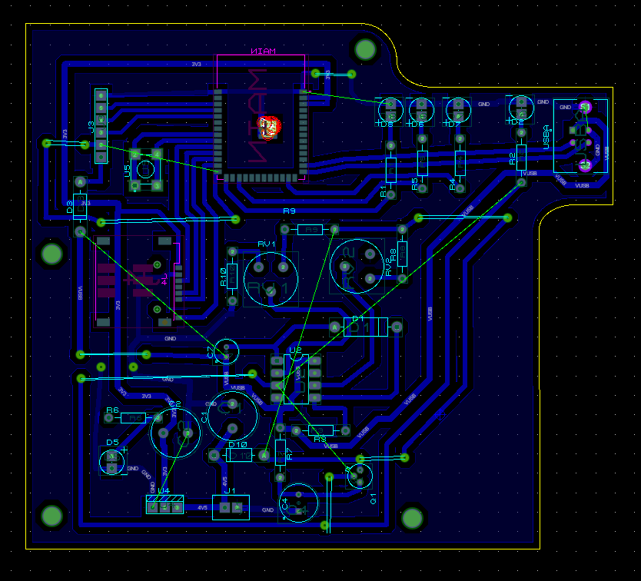

Figure 27. PCB layout of the final product WEUSBFD

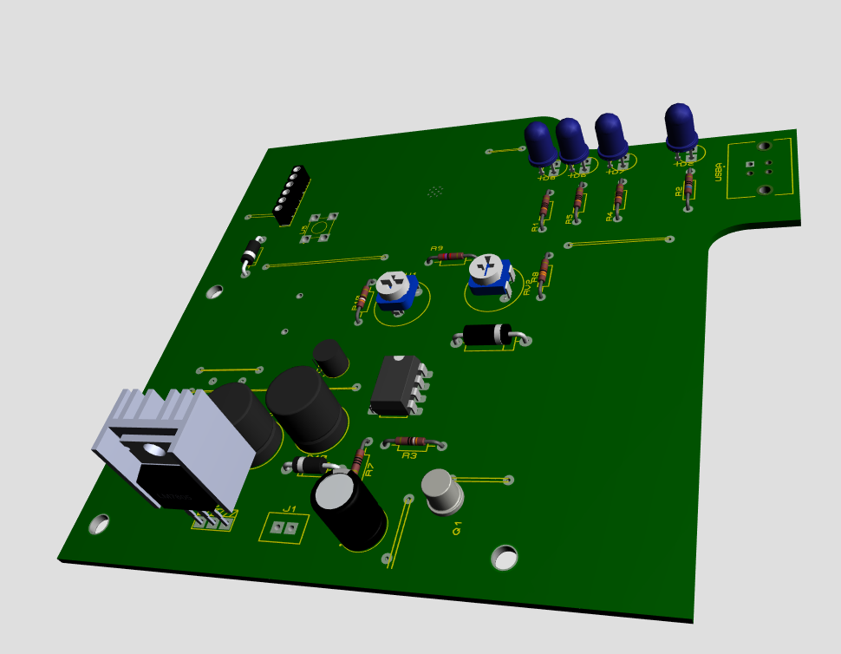

Figure 28. 3D view of PCB of WEUSBFD

### ESP32 Based USB Flash Drive

As one of the objectives to accomplish the normal usb functionality was now possible. The following is the simplified design of the usb flash Drive.

The usb flash drive featured the following

* + 1. ESP32S3 core controller
    2. Usb type C 2.0 connector
    3. EMMC128TX298 a 128GB SD_MMC memory with up to 120Mbps speed.
    4. Low Drop Voltage regulator to control power between the usb and ICs

The details can be visible from the figures below

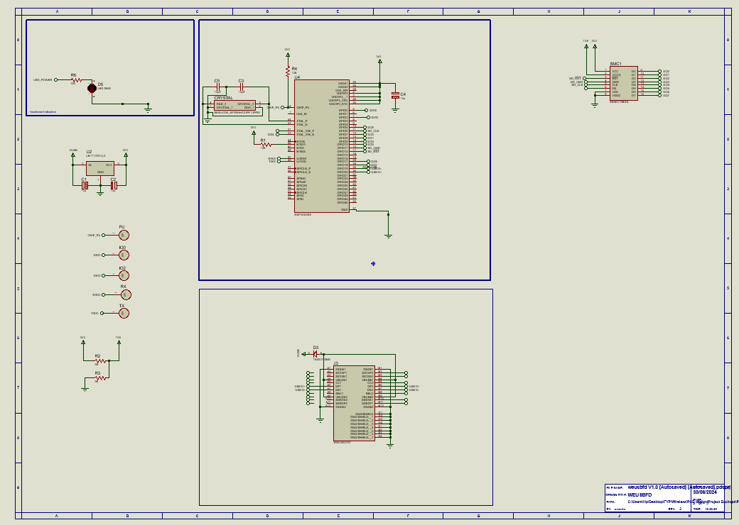

Figure 29. Final Usb flash drive Schematic

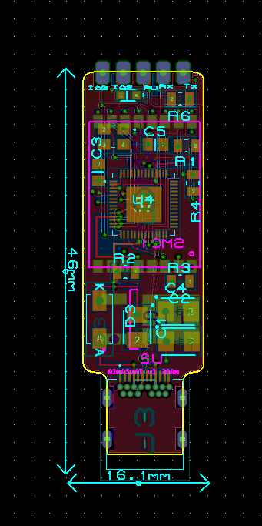

Figure 30. Final Usb flash Drive PCB layout

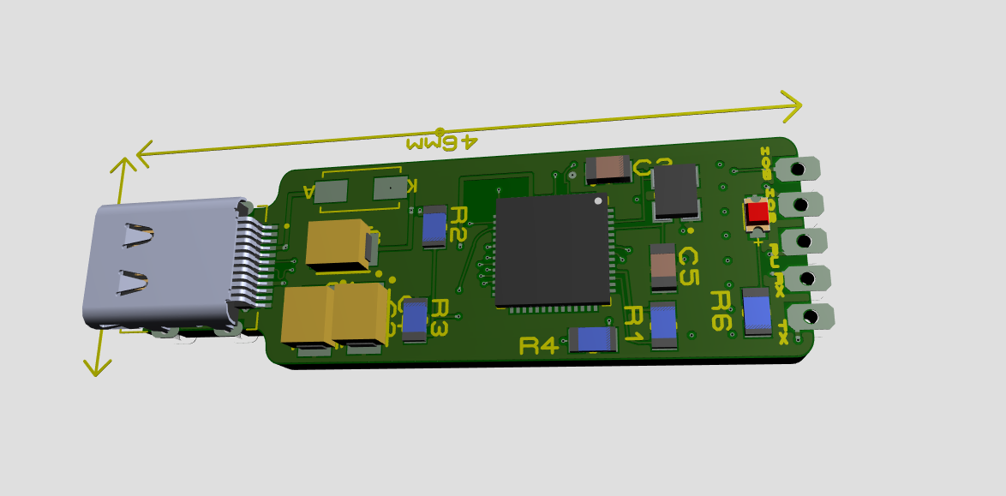

Figure 31. Final USB flash Drive 3D view

## CONCLUSION

### Recommendations

In order to accomplish this endeavor, the following theories should be considered:

* + 1. To optimize the usb flash drive speed and to reach the commercial usage and requirement, the newer types of storage protocols should be preferred as NAND and NOR parallel chips are old and slow already.
    2. Move the requirement of SMB Server to operating systems or rebuilding using higher level of processing including operating systems like Linux.

### Challenges

Despite the minor challenges, major challenges I was facing during implementation of project was

1. Documentation. Since most of the documentation and resources are online there was a challenge in increasing the budget due to increased demands on resources.
2. Low community. Despite using Arduino with large community such complexity of this project led to low support from other members.
3. Utilities, due to the demand of this project is high, most of the utilities like esp32s3 where unavailable in the local market hence led to waste of time during delivery
4. In spite of being able to utilize maximum frequency of es32s3 of about 240MHz the microcontroller still does not provide the expected results as 40MHz for GPIO switch frequency and can only provide 26MHz only.

Generally, the term “file management” may fall to a very unstable, important and delicate subject in most of the operating systems hence it requires a high level of handling and care when doing data transfer.

# REFERENCES

al, J. W. (2016). A Survey of Mobile Storage Systems: Flash Drives, SD Cards, and Wireless Flash Drives .

Barnes, R. (2017). Make a Pi Zero W Smart USB flash drive. The MadPi Magazine.

Bez, R. (2004). Non-volatile memory technologies: emerging concepts and. Materials Science in Semiconductor Processing 7 (2004) 349–355, 7.

Bogart, D. J. (1995). Magnetic Tape Storage and handling . National Medial Lab.

Czapor, J., Hartney , B., & Knight , A. (2006). Wireless USB Flash Storage Device. google scholar.

Digital, W. (2022). Wireless Flash Drive: End of Support. United States: Wetsern Digital.

Hyperstone. (2020). Introduction to: Non Volatile Memory. Hyperstone. Retrieved from www.hyperstone.com

IEEE. (2007). For Wireless USB, the Future Starts Now. IEEE.

# APPENDICES

## TIME SCHEDULE

The image below shows the time distribution for this project throughout the provided timeline

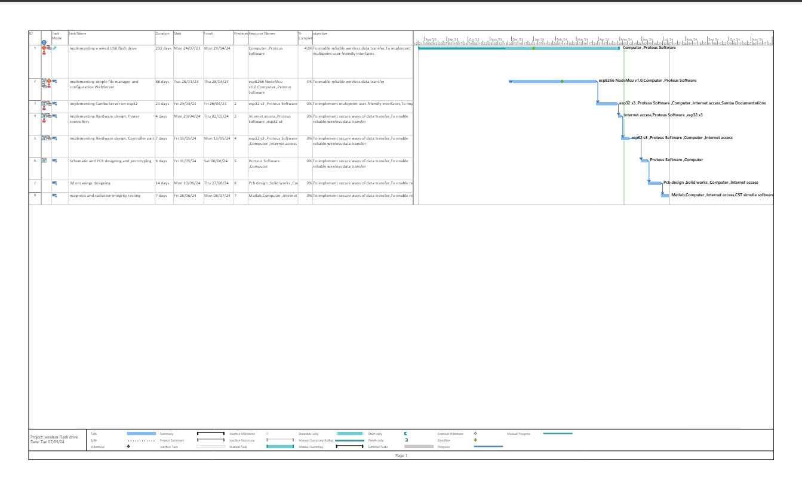

Figure 32.Time Schedule

## BUDGET

This table comprise of the cost that were used in design and may change due to change in scope

|  |  |
| --- | --- |
| Components | Cost (Tsh) |
| Esp8266 nodeMcu module | 20,000/= |
| Memory card | 10,000/= |
| Memory card module | 8,000/= |
| Esp32 s3 | 45,000/= |
| Breadboard | 15,000/= |
| Lithium-ion Battery | 20,000/= |
| Battery controller (NE555) | 5,000/= |
| Nand memory storage chip | 5,000/= |
| Connecting wires | 10,000/= |
| USB connector | 1,000/= |
| Internet Access | 120,000/= |
| 3D encasing | 80,000/= |
| Nand flash Memory | 20,000/= |
| LDO converter | 3000/= |
| USB JACK | 5000/= |
| Capacitors | 2500/= + 3000/= |
| Resistors | 2000/= + 2600/= |
| Push Button | 4000/= |
| Diodes | 2000/= |
| Total | 383,100/= |